**University Policy Flow Chart**

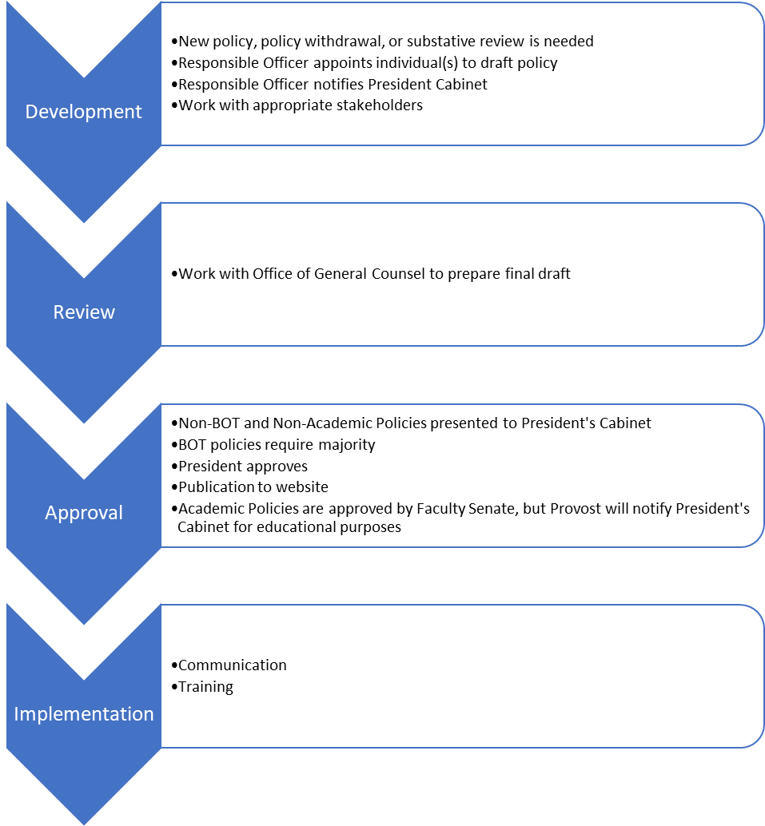

**Academic Policy Flowchart**

